18th June 2020
Dear parent/carer,

Since I last wrote to you, our staff have been working hard with the return of Reception, Year 1 and Year 6 in addition to keyworker children. We are so impressed with the children who have settled into their new routine quickly and with smiles on their faces. Thank you all for preparing them so well and for your positive feedback:

‘I'd like to a huge thank you and congratulations for such a successful first day back to school. I have a very happy and stimulated child that hasn't stopped cheerfully chatting about his day. We are lucky to be part of such a forward thinking school.’

‘Thank you – you are all working so very hard to strike the right balance between the children’s education and their physical and emotional well-being.’

The national picture is not so positive. The DfE estimates that around 9.1% of pupils are currently attending school with only 67% of schools open to at least one of the priority year groups (nursery, reception, year 1 or year 6). In schools open to these year groups, attendance in reception and year 1 was approximately 30% and year 6 attendance was just under 40%. At South Farnham we have over 90% of children in each priority year group attending.

For those children not in school, our outstanding remote learning provision includes LOOM videos from the teachers, weekly ZOOM class assemblies and a wealth of teaching materials. From next week, we will be increasing the frequency of LOOM videos for Years 2, 3 and 4 to include daily English and Maths provision. There will also be foundation LOOMs and a weekly reading from their class teacher from their class reader book. Thank you to everyone submitting work through the website; the teachers are keen to be providing feedback to the children. We would like to encourage Year 2, 3 and 4 to submit more work for feedback (more than one submission a week as previously stated).

From Monday 22nd June we would like to welcome back children in Year 5.

Our school risk assessment is available on our website: https://www.south-farnham.surrey.sch.uk/page/?title=COVID%2D19+%2D+Return+to+School&pid=317. We have taken every reasonable endeavour to follow government advice and to adhere to the social distancing guidelines available to schools. All the staff are dedicated to making the children’s return to school, following ‘lockdown’, as comfortable and welcoming as possible. We understand that parents and children may be anxious; please take some time to watch our ‘bubble video’ and discuss with your child what school will look like when they return on Monday. It is also available on YouTube: https://youtu.be/RGNi0mEmwpI
 | Welcome Back to School! (COVID-19 Return to School)  All the staff at South Farnham School are dedicated to making the children’s return to school, following ‘lockdown’, as comfortable and welcoming as possible...  youtu.be

Please find below the necessary arrangements.
Arrival and collection at school

- We recommend no unnecessary use of public transport to/from school.
- Only one parent/carer to accompany their child(ren) to/from the school site.
- Children walking to and from school unaccompanied should practice social distancing – parents need to discuss this with their child.
- Children to come straight into class at the beginning of the day at their allocated time (not going to playground to play or entering cloakrooms). Cloakrooms will not be used. The gate to the playground will be locked at the Junior site.
- There will be no extended school provision i.e breakfast buddies or after school care (except for key worker / vulnerable children). This is to prevent children mixing outside their ‘bubble’.
- If any child is upset at the beginning of the day we ask that the parent takes responsibility to avoid contact with the teacher, taking them home if necessary.
- Staggered arrival and collection times as shown below.
- Agreed entry points shown in map attached.

JUNIOR DROP OFF AND COLLECTION
Group | Arrival time | Collection time
5D | 8.35am | 3:05pm
5F | 9.05am | 3.35pm
5S | 8.55am | 3.25pm
5W | 8.45am | 3.15pm

Safety measures

- An in-depth risk assessment is available on our school website.
- No parent/guardian to enter site without a pre-arranged appointment (unless dropping off/collecting).
- Frequent handwashing is timetabled across the school day. All children will be expected to adhere to our handwashing procedures, regardless of whether they choose to also bring hand sanitiser to school.
- All classrooms are equipped with a sink, soap, paper towels and cleaning equipment.
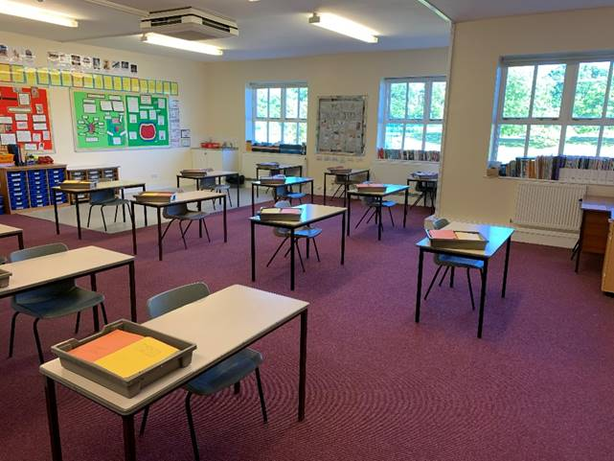
This is an example of a classroom.

- Door handles, banisters etc. to be cleaned regularly.
- Children will be arranged in small groups (‘bubbles’) with a maximum of 15 pupils. These bubbles are arranged using register order and we will be unable to change these to ensure we safeguard all those within the bubble.
- The children remain in their bubbles each day, with the same staff and in the same room.
- Children will be seated at the same desk each day with their own supply of essential stationery and their water bottle on their desk.
- Temperatures of all children will be taken during morning and afternoon sessions.
- Staff and children are not required to wear PPE. Safety guidelines will be adhered to when administering first aid or intimate care.
- Please could we ask that where possible medicines are administered before and after school.
- There will be minimal movement within the classrooms and around the school.
- Staggered breaks and lunchtime to avoid overcrowding in corridors at these times.
- Children will eat lunches in their bubbles outside (or inside classroom if weather is poor) with a lunch break of 45 minutes. Each bubble will have a designated playzone which will not change and will be supervised by the staff allocated to their bubble.
- Where it is safe to do so doors and windows will be open to provide ventilation.
- PE lessons will be non-contact and limited to the children in one bubble (not mixed).
- If a child presents symptoms during the day they will be referred to a ‘quarantine’ room. Parents will be contacted immediately by an appropriate member of staff to collect their child from school. Where self-isolation is recommended government guidance should be adhered to. Self-isolation of those in contact with a confirmed case (following testing) should be adhered to.
- Any children/staff who display coronavirus symptoms (or have someone in their household who does) must not attend school and follow guidelines for self-isolation. The school office should be notified of this.

What to wear and bring?

- Summer school uniform, including school shoes, to be worn. Ties should not be worn. We would advise you to wash uniform every day. Children will take part in PE in the clothes they are wearing (avoiding children changing and therefore minimising movement and contact)
- If a child brings in a coat/jumper they will keep this on their chair. Cloakrooms will not be used.
- School lunches will be available as usual via parentpay. This MUST be booked and paid in advance by the Wednesday before the selected week. We will NOT be able to provide a lunch if it has not been pre-booked. Please note if you need a packed lunch for the first week please email the school office at info.southfarnham@sfet.org.uk – you will be unable to book online.
- Children opting for a school lunch will be provided with an ‘easy’ packed lunch so staff do not need to handle food/packaging. Children must bring in their own named water bottle.
- For those bringing in a packed lunch they will bring this into their classroom and keep this with them. Food provided from home should not require teacher assistance with opening.
- If necessary sun cream should be applied before coming into school.
- No other items from home should be brought into school, including backpacks.
- Please ensure all items are clearly labelled so they easily stay with your child.

Thank you for your continued support. Please let us know by emailing sfsremote@sfet.org by Friday 19th June if your Year 5 child is unable to attend for any reason.

Transitions for September

At the moment, we are planning for ‘business as usual’ in September. Whatever happens, all the staff at South Farnham are dedicated to making the children’s return to school as comfortable and welcoming as possible. Please rest assured that extensive planning is well underway regarding every child’s transition to their new year group. Before the end of term you will receive a video from your child’s new class teacher introducing themselves. For the new Reception and Year 3 children we are opening the school on Saturday 4th July to give the new children the opportunity to meet their teacher, see the classroom, facilities and play areas. We will be dividing the class into two halves by register order as we cannot have all the children in school at the same time. You will receive information via email on the exact arrangements of your ‘bubble’ for that morning. The times are as follows:

Infants: Session 1 will run from 9.30 – 10.15am and session 2 from 10.30 – 11.15am.
Juniors: Session 1 will run from 9.00 – 9.45am and session 2 from 10.00 – 10.45am.

Well-being

We understand that parents and children may be anxious and all staff will be focused on mental health and well-being when the children make their transition. I know many of you are worried about how much teaching the children have missed and that they may have ‘fallen behind’. Again, we are ready to support every child’s learning and minimise and gaps in their knowledge.

A number of our families have been affected by bereavement through COVID-19 and the school is offering available support individually to those who have contacted me. If your child is returning to school and there is any specific information you would like me to be aware of please let me know. Additionally, as I have said in previous correspondence, the school is here to support the children who are not at school. Please keep in contact, especially through the submission and forum pages on the website. Please be assured that whilst the daily routine has changed, staff enthusiasm and passion for teaching and pastoral care remains the same.

Remote learning, available on the website, will continue for all year groups (including Reception, Year 1, Year 5 and Year 6) along with ZOOM assemblies for Year 2, 3 and 4. Thank you again for your continuous support in helping your child learn from home while juggling work and other commitments.
At South Farnham we approach everything with a ‘can do’ attitude. While many schools around us remain closed to the majority of pupils, we are doing all in our power to welcome more children back to school as long as it is safe to do so. However, we must remember we are in the middle of a global pandemic and, as a community, we are living in circumstances which seemed unimaginable a few months ago. It is not perfect, but we must all continue to try our best.
Yours sincerely,

Claire Donnachie
Headteacher

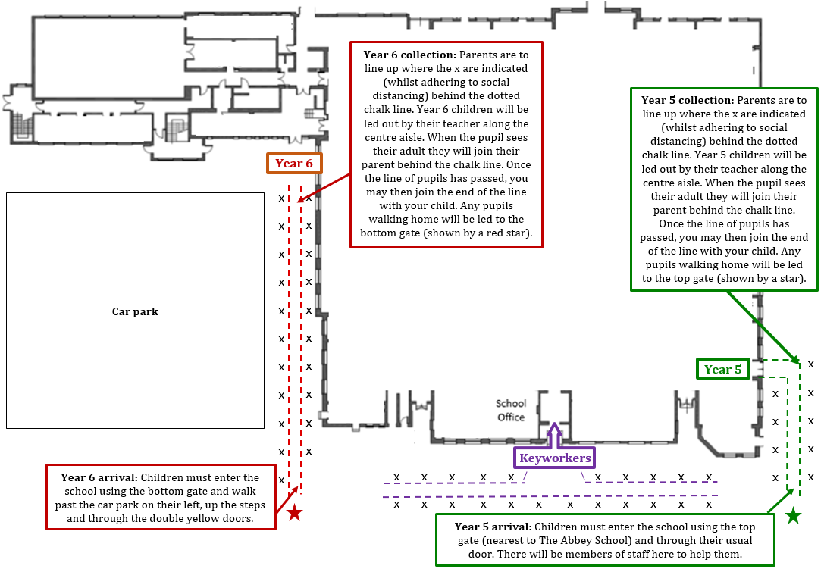
Junior Site: Year 5, 6 and Year 3 and 4 Keyworkers

