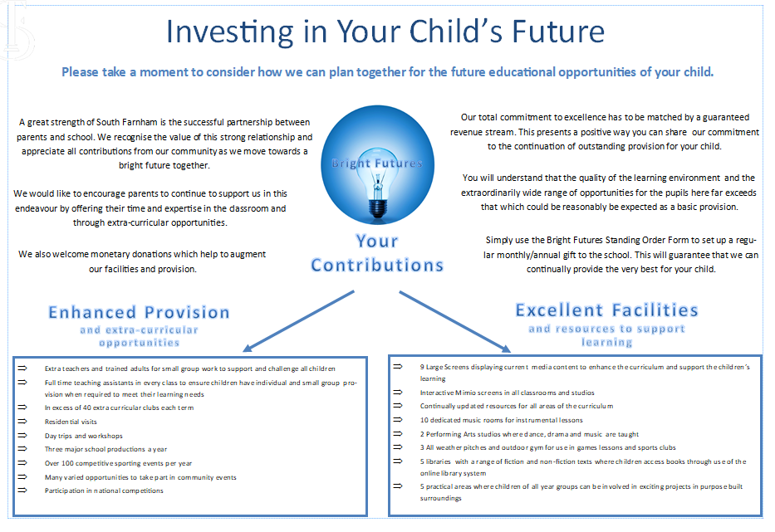

BRIGHT FUTURES STANDING ORDER FORM
To be returned to South Farnham School

Please pay the sum of £ ……………… per month / year (delete as appropriate) to:
THE SOUTH FARNHAM SCHOOL TRUST
BARCLAYS BANK FARNHAM
Account Number: 90822043 Sort Code: 20-31-06
The first payment to commence on: ……………………………………
Signature:…………………………………… Date: ………………………………

Your Bank Account Details:
NAME OF BANK: …………………………………………………………………………
Address: …………………………………………………………………………………….
Account Holder’s Name: …………………………………………………………….
Account Number: ………………………………….. Sort Code: …………………………………..

GIFT AID DECLARATION

I confirm that as a donor I am a tax payer and that I hereby require The South Farnham School Trust to treat all donations I make from the date of this declaration, unless I notify you otherwise, as gift aid donations.
Signature: ……………………………………. Date: ………………………………………
Title: ……………… Forename: …………………………
Surname: …………………………………….
Address: ……………………………………………………………………………………………………………..……………………………………………………………….
Post code: …………………………………….
Charity Gift Aid Declaration
South Farnham School Trust
Registered Charity No. 802541
Boost your donation by 25p of Gift Aid for every £1 you donate
Gift Aid is reclaimed by the charity from the tax you pay for the current tax year. Your address is needed to identify you as a current UK taxpayer.

In order to Gift Aid your donation you must tick the box below:

I want to Gift Aid my donation and any donations I make in the future or have made in the past 4 years to South Farnham School Trust.

I am a UK taxpayer and understand that if I pay less Income Tax and/or Capital Gains Tax than the amount of Gift Aid claimed on all my donations in that tax year it is my responsibility to pay any difference.

My Details
Title ________________
First name or initial(s) _____________________________
Surname _______________________________________
Full Home address ________________________________________________________________
________________________________________________________________
Postcode ____________________
Date ___________________________________

Please notify the charity if you:
- want to cancel this declaration
- change your name or home address
- no longer pay sufficient tax on your income and/or capital gains
If you pay Income Tax at the higher or additional rate and want to receive the additional tax relief due to you, you must include all your Gift Aid donations on your Self-Assessment tax return or ask HM Revenue and Customs to adjust your tax code.
Signature __________________________ Date ______________________

Child ____________________________ Class ______________________

